2019 Summer Assignment - Eng. 3B (133)- Mrs. Stager

All students in Eng. 3B (133) are required to read the novel Boys Don’t Knit (In Public) by T.S. Easton AND complete the study guide- see link. The study guide is due on the first day of school. Students should be prepared to discuss the novel and write an essay during the first few weeks of school. Books are available through all major book retailers in paper or e-book format and from local libraries.
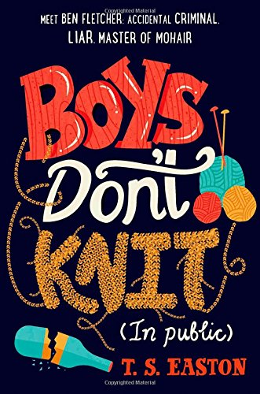
About the novel: After an incident regarding a crossing guard and a bottle of Martini & Rossi (and his friends), 17-year-old Ben Fletcher must take up a hobby and do some community service to avoid any further probation. He takes a knitting class with the impression that it's taught by the hot teacher all the boys like. Turns out, it's not. Regardless, he sticks with it and comes to discover he's a natural knitter, maybe even great. It also helps ease his anxiety and worrying. The only challenge now is to keep it hidden from his friends, his crush, and his soccer-obsessed father. What a tangled web Ben has weaved- or knitted. (source: bn.com)

Link to study guide: https://docs.google.com/document/d/1PE2jeMReO_Xszk2NfdAtHLIWs4E9UPAIZjeZjno0xYI/edit?usp=sharing

